Team: **Matlabbers**

Tara Safavian (917718757)

Alexia Rocha (918580463)

Aditya Joshi (918859330)

Card Game: Blackjack

**General Blackjack Rules/Information**

* Non-casino rules (1 deck of cards in play)
* Start with 20 chips
* General rules: <https://www.blackjackapprenticeship.com/how-to-play-blackjack/>

**Rough Design**

* See image below

**Assigning Cards**

* fullDeck -> 1x52 array
* Cards dealt -> cards = []
* playerCard = randsample([fullDeck],2)
* WorkingDeck = fullDeck
* WorkingDeck(playerCard) = []
* WorkingDeck = fullDeck - ‘playerCard’
* If sum(playerCard) = 21
  + Player wins
* elseIf sum(playerCard) > 21
  + Player loses; Stop dealing
* elseIf sum(playerCard) < 21
  + Choose ‘hit’ or ‘stand’
* Player chooses ‘hit’ or ‘stand’
* If ‘hit’
  + NewCard = randsample([fullDeck],1)
* elseIf ‘stand’
  + Player loses; Stop dealing
* If length(WorkingDeck) <= 26
  + WorkingDeck=fullDeck
* fullDeck [sA s2 s3 …s10 sJ sQ sK.]
* Points [aces 2 3 ….. 10 10 10 10 aces 2 3 ….. 10 10 10 10]

|  |  |
| --- | --- |
| Week 7 | * Create deck * Random generator function * Scores * Betting Money |
| Week 8 | * Interface / UI stuff   + Simulink * Deal with Aces |
| Week 9 | * Scores * Betting * Sounds + animation |
| Week 10 | * Sounds + animation cont. (if needed) * Be sure code is running correctly * Add bonus features if able(?) |

Tara Alexia Aditya

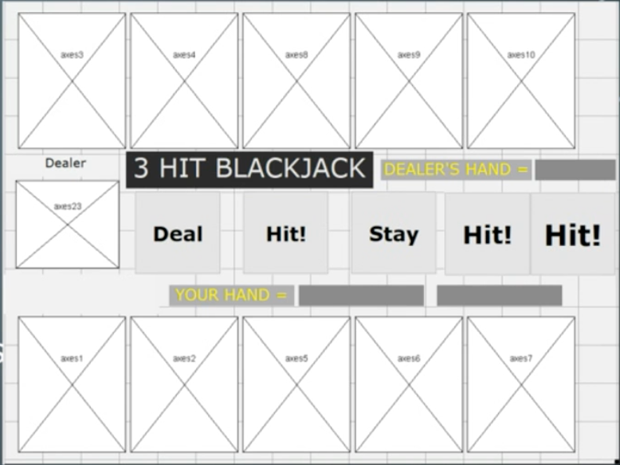

1. All players bet
2. Players are dealt 2 cards
3. Players decide to hit or stand
   1. Hit
   2. Stand
4. Hit: players are dealt 1 card
   1. Go back to 3
5. If sum(hand) > 21, automatically bust
6. Continue to cycle until everyone stands
7. Stand: